

`

TOM Integration

Interface Specification on
Actual Range in Store from
GFO to Store Range
=

[S077]

Project BEN Code: | W60416
Author: | Nitin Singhai
Date: | 16/03/2007
Version: | 1.0
Status: | Draft
Modified By:
Reviewed By:

Change Record

Author | Date | Version | Change Reference, description
Nitin Singhai | 16-03-2007 | 0.1 | Initial Draft
Nitin Singhai | 06-06-2007 | 0.2 | Updated the folder structure in Section 2.2 and 2.3.
Nitin Singhai | 25-06-2007 | 0.3 | Updated the target SR file name.
Nitin Singhai | 29-06-2007 | 1.0 | Updated the Biztalk Package Name

Reviewers

Name | Date | Version | Position

At least one reviewer is required.

Sign-Off

By signing this form, I understand and agree with the contents of this document.

Business Owner/Customer | Andrew Barker
Position | Engagement Architect
Signature | <Physical signature or via email approval>
Date | dd/mm/yyyy (<version signed off>)

Distribution List

Name | Date of Issue | Version
Jon Braggs
Andrew Barker
David Onyett
Mary Welch

Document Source

Related Documents:
File Name:

Information Architecture Context diagram

Mapping spreadsheet
S077 Actual Range in Store (GFO to SR) Mapping Spec
Table of Contents
1 Introduction 6
1.1 Purpose of Document 6
1.2 Background 6
1.3 Scope 6
2 Description and Requirements for the End-to-End Interface 7
2.1 Description of the End-to-End Interface 7
2.2 Architecture 7
2.3 Requirements for the End-to-End Interface 8
3 Processing required in an Extract-Stage of the interface 9
3.1 Scope 9
3.2 Source Message Schema 9
3.3 Message Format 9
3.4 Message Transport Details 9
3.5 Naming and Configuration 10
3.6 Environment and Security Context 10
3.7 Non-Functional Requirements 10
4 Processing required in the Messaging Stage of the interface 12
4.1 Scope 12
4.2 Data Validation 12
4.3 Filtering 12
4.4 Mapping 12
4.5 Target Message Schema 12
4.6 Message Format 12
4.7 Message Transport Details 13
4.7 Naming and Configuration 14
4.8 Environment and Security Context 14
4.9 Non-Functional Requirements 14
5 Processing required in the <third stage of the interface> 15
5.1 Scope 15
5.2 Data Validation 15
5.3 Filtering 15
5.4 Mapping 15
5.5 Target Message Schema 15
5.6 Message Transport Details 15
5.7 Naming and Configuration 15
5.8 Environment and Security Context 15
5.9 Non-Functional Requirements 15
6 Testing Deliverables 16
7 Deployment 17
8 Assumptions and Outstanding Issues 18
8.1 Assumptions 18
8.2 Outstanding Issues 18
Appendix A Volumes 19
Appendix B Glossary 20
Appendix C Document Control 21

Introduction

Purpose of Document
The purpose of this document is to describe the interfacing requirements w.r.t Store / Product Range Details.
The document is of a sufficiently technical nature to allow a developer to build an actual interface. Additionally the document contains detail that might sit logically within a Technical System Design (TSD) document, but is contained here for expediency. There is therefore no associated TSD for this interface.

This interface is for US and Turkey implementations.

Background
As part of Tesco Operating Model program, there is requirement to bridge the functionalities of enterprise applications including GFO and SRD Store Range. To achieve this functionality, high level process flow architecture has been designed and approved by TESCO Enterprise Architecture team. As part of this process flow architecture there is a set of interfaces that has been identified to be developed to transfer Store Range data from GFO to SRD Store Range Database.

Scope
The Interface Specification covers:

- audit requirements across the interface
- security requirements across the interface
- timing/frequency requirements or constraints
- support requirements
- archiving
- the data format to be used for the interface at each stage
- the normal processing required at each stage
- recovery from failure required at each stage
- volumes.

Note that it is Tesco strategy to avoid placing any business logic in integration layer processing.

Description and Requirements for the End-to-End Interface

Description of the End-to-End Interface
The interface is a batch extract of Group Forecast and Ordering (GFO), from a flat file (positional) and uploads into SRD Store Range. The Upload is a delta upload in nature. It is application’s responsibility to provide the deltas to integration layer.

The interface is meant to run at a pre-configured time interval, which on completion is expected to produce flat file. The Integration Layer will do necessary transformation to produce the required Store Range File. The file produced successfully is placed into the SR \ Inbox Shared location. This shared location would be monitored by Store Range systems Interface at the same interval. Once the file containing the extracted data appears on the shared location it should load the data (updates/inserts) into Store Range Database by Internal Processes of Store Range System.

Integration layer will move the file from GFO OUTBOX folder to GFO Archive folder once this interface executes successfully.

If any error occurs while processing the Source file, the file should be moved to IL \ ERROR folder.

The interface will make use of the audit and traceability components that are being developed as part of the Operational Framework stream. Developers should put a ‘placeholder’ in their code / configurations as appropriate.

Architecture
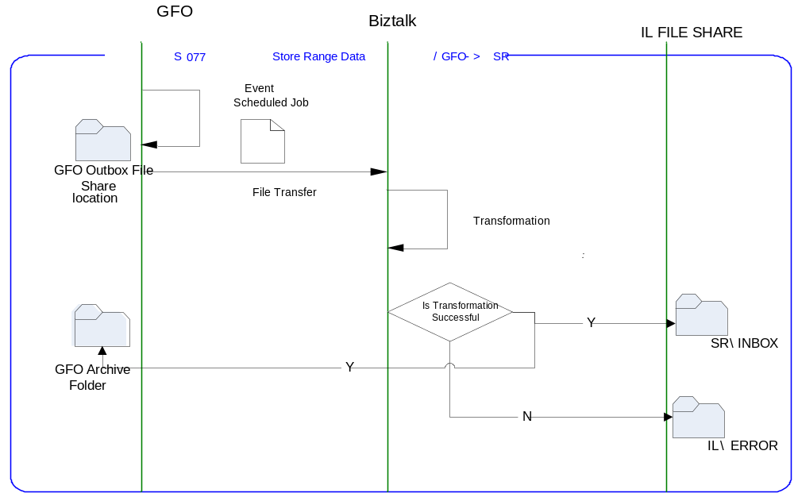

Requirements for the End-to-End Interface

Audit Requirements | The interface will use the components provided by the Operational Framework to satisfy audit requirements.
Security Requirements | The interface executes within a secure private domain. There are no additional security considerations required.
Timing/Cut-off Constraints | To be finalised.
Performance Requirements | The interface should be capable of extracting data in the form of flat file from the shared location at GFO side and delivering the resulting to another shared location at Store Range side before the identified cut-off time. The interface should run as a batch process.
Reliability and Availability Requirements | The interface-run should be atomic in nature. Where it is not possible to implement an atomic nature of interface, appropriate mechanisms should be in place to raise/alert appropriate parties.
Scalability Requirements | N/A - No scalability issues exist.
Operational Support Requirements | No such requirement has been agreed upon at the time of writing this document. However, it is perceived that there would be interface support requirements after go-live date that would require an evaluation.
Likelihood of Change Requirements | There is no such requirement
Cultural/Global Consideration Requirements | N/A
Legal Requirements | N/A
Compliance To Standards Requirements | No compliance exceptions.

Processing required in an Extract-Stage of the interface

Scope
GFO pushes a positional flat file containing the Store Range data, to a predefined shared location. The flat file is created at a predefined time interval. Once the file is created at the shared location, BizTalk picks up the file, transforms the file into a flat file and pass the file to another shared location accessible by Store Range for further processing.

Source Message Schema
Field Name | Record Type | Data Type & Size | Starting Position | Notes
JLCXA-CR-TO-CRST-XFER-HDR | 01
JLCXA-RETAIL-OUTLET-NO | 03 | PIC 9(5) | 1 | (Record Type ‘00000’ for Header)
JLCXA-DATE-CREATED | 03 | PIC X(10) | 6 | Date (CCCC-MM-DD) of sent file.
JLCXA-CREATE-TIME | 03 | PIC X(5) | 16 | Time (HH:MM) of sent file
JLCXA-CA7RUNNO | 03 | PIC X | 21
FILLER | 03 | PIC X(36) | 22 | SPACES
JLCXB-CR-TO-CRST-XFER-REC. | 01
JLCXB-RETAIL-OUTLET-NO | 03 | PIC 9(5) | 1
JLCXB-BASE-PRODUCT-NO | 03 | PIC 9(9) | 6
JLCXB-STKD-PROD-STDT | 03 | PIC X(10) | 15
JLCXB-STKD-PROD-ENDT | 03 | PIC X(10) | 25
JLCXB-CR-RNGE-SRCE | 03 | PIC X | 35
JLCXB-ACTL-RNGE-IN-DT | 03 | PIC X(10) | 36
JLCXB-ACTL-RNGE-OUT-DT | 03 | PIC X(10) | 46
JLCXB-PROM-IND | 03 | PIC X | 56
JLCXB-ON-PROMOTION | 88 | VALUE "Y”
JLCXB-NEG-BOOK-STOCK | 03 | PIC X | 57
JLCXZ-CR-TO-CRST-XFER-TRLR. | 01
JLCXZ-RETAIL-OUTLET-NO | 03 | PIC 9 (5) | 1 | (Record Type ‘99999’ for Header)
JLCXZ-REC-COUNT | 03 | PIC 9(9) | 6 | Record Count
FILLER | 03 | PIC X(43) | 15 | SPACES

Message Format
The source message is in the form of positional file from GFO and is getting converted into the target file format in a package. The following sample message format is the source message format.

The sample file will be attached.

Message Transport Details

Feature | Specification | Additional Information
Source System Name | GFO
Source Platform / OS | UNIX –AIX 5.3
Source Physical Location | GFO_Output
Source Underlying Data Storage Technology
Target System Name | BizTalk 2006
Target Platform / OS | BizTalk 2006 Server
Target Physical Location
Target Underlying Data Storage Technology | File Share
Transfer Function | HTTP (Put/Post) □  HTTPS (Put/Post) □  Message Queue □  FTP □  File Drop(Windows) ☑  RTI Adapter □
Data Format. | XML □  Delimited □  Positional ☑
Decryption/Encryption | No
Decompression/Compression | No
Transmission Mode | Synchronous □  Asynchronous ☑  Bulk Data □
Real-time/Scheduled Batch | Not yet decided
Archiving | Archiving of Source File should happen. Once the Interface has finished its run successfully, the file should be placed to GFO Archive Folder GFO_Archive.
Logging | Logging should occur, such that the message can be recreated if necessary.
Error Handling | Not yet decided  Processing should prevent sending of duplicate messages, unless this occurs during recovery from failure.

Naming and Configuration

Biztalk – 2006
Package Name: TOM.S077.GFOtoStoreRange
BizTalk Procedure
Name
<Placeholder for other package components/steps>
<Placeholder for other package components/steps>

Environment and Security Context
Account details will be included here once we have visibility of the environments.

Non-Functional Requirements
Not Applicable

Processing required in the Messaging Stage of the interface

Scope
BizTalk monitors the file in the configured location for every new file and submits the same to the remote file share as a File Drop. The resultant file is a flat file.

Data Validation
Data Validation will be done by the target Target- Store Range system.

Filtering
There is no filtering requirement.

Mapping
Mapping document will be provided subsequently.

Target Message Schema
Target File Name: <bussinessdate>_SR77_ActualRange_<YYYYMMDDHHmMss>.txt

Field Name | String | Length | Starting Position | Occurs | Notes
Header Record |  | 56 |  | 1:1
HeaderRecType | CHAR | 1 | 1 |  | Integration layer to set the record type to 0
RUNDATE | CHAR | 10 | 2 |  | YYYYMMDD
RUNTIME | CHAR | 6 | 12 |  | HHMMSS
FILLER | CHAR | 39 | 18 |  | SPACES
Detail Record |  | 56 |  | 1:*
DetailRECTYPE | CHAR | 1 | 1 |  | Integration layer to set the record type to 1 for detail
Store Number | Integer | 5 | 2
Base Product Number | Integer | 9 | 7
Stock Start Date | Datetime | 10 | 16
Stock End Date | Datetime | 10 | 26
Stock Reason Code | CHAR | 1 | 36
Actual Range In Date | Datetime | 10 | 37
Actual Range Out Date | Datetime | 10 | 47
Trailer Record |  | 56 |  | 1:1
TrailerRECTYPE | CHAR | 1 | 1 |  | Integration layer to set the record type to 9 for trailer
RECCOUNT | CHAR | 9 | 2
FILLER | CHAR | 46 | 11

Message Format
The source message is a positional flat file from GFO and is getting converted into the target file format for Store Range in a package. The target message is a flat file.

4.7 Message Transport Details
For messages destined for Store Range system, the following applies.

Feature | Specification | Additional Information
Source System Name | BizTalk 2006
Source Platform / OS | BizTalk 2006 Server
Source Physical Location
Source Underlying Data Storage Technology | File System
Target System Name | SRD Store Range
Target Platform / OS | Windows 2003 Server
Target Physical Location | Tba
Target Underlying Data Storage Technology | File Share
Transfer Function | HTTP (Put/Post □  HTTPS (Put/Post) □  Message Queue □  FTP □  File Drop (Windows) ☑  (XCOM) □
Data Format | RIB Message □  XML □  Delimited □  Positional ☑
Decryption/Encryption | No
Decompression/Compression | No
Transmission Mode | Synchronous □  Asynchronous ☑  Bulk Data □
Real-time/Scheduled Batch | Real-time
Archiving | There is no archiving requirement
Logging  Should logs be kept of all actions? For how long should these be stored? | Logging should occur, such that the message can be recreated if necessary.
Error Handling | Not yet decided

Naming and Configuration

Biztalk 2006
Instruction Name:
Instruction Details
Description | To be determined
Enabled | True
Type
Operational Window
Schedule | N/A
Enabled | False
Host Details
Account | To be determined
Operational Details
Worker Threads
Priority
Batch Size
Period
Retry Attempts
Timeout
Require Data Send
Exception Management
Treat Fatal Adapter Exception As
Treat Unhandled Exceptions As

Environment and Security Context
Account details will be included here once we have visibility of the environments.

Non-Functional Requirements
On successful delivery of the file to the target system, the audit log should be updated via the Operational Framework pipeline component or adapter (to be determined).

In the event of a failure the file should be written to the failed files location, and an alert should be raised.

Processing required in the <third stage of the interface>

Scope
There is no intermediate staging is required for this interface. So this section is not applicable.

Data Validation
Not Required

Filtering
Not Required

Mapping
Not Required

Target Message Schema
Not Required

Message Transport Details
Not Required

Naming and Configuration
Not Required

Environment and Security Context
Not Required

Non-Functional Requirements

Not Required

Testing Deliverables
Unit Test Scripts and test cases are kept at the following location <location>

Deliverable | Description
TBD <stored proc name> | Stored Procedure
TBD <stored proc name> | Stored Procedure
TBD <service name> | Web Service
TBD <SSIS package name> | Package
TBD <RTI configuration file> | Xml configuration file exported from RTI. For testing, this should contain the configuration required to support this interface only.  For production, configuration should be documented under section 7 Deployment.
TBD <script name> | Unit Test Scripts. Scripts should be provided to:  - create databases (including stored procedures).  - populate with the minimum set of test data to satisfy functional requirements  - notes showing how to use scripts and describing the functions tested.
<installer> | Installers as appropriate to the technology being used.

Deployment

Assumptions and Outstanding Issues

Assumptions
ID | Assumption
1 | The target file format has not been decided at the time of writing this document from store range system. So the format provided is assumed at this point of time

Outstanding Issues
ID | Issue | To be addressed by
1 | Target File name and Target location to be confirmed | Store range team
2 | Timing requirements of interface not established. | Store range team
3 | Understand impact of non-delivery of the file. | Store range team
4 | The design of the IMOF is still being worked and will require retro-fitting to the interface. | IMOF team
5 | Alert numbers/identifiers are yet to be defined. | Integration Solution Architect

- Volumes
- Glossary

Acronym | Term | Description
EAI | Enterprise Application Integration | The process of meeting the data requirements of applications by providing a message based transport from disparate data sources across all forms of enterprise technology.
EAI Layer | Enterprise Application Integration Layer | Refers to the integration services provided to implement EAI. In contrast to the EIA Layer for data services. See below.
EIA | Enterprise Information Architecture | Creation of a strategic single view of data across the enterprise.
Interface | Interface | Many definitions exist for 'interface'. In general, 'interface' refers to the link between a data source and a data target. And there are properties of the interface in this context. However more specifically 'interface' refers to one end of a data link, hence the terms source interface and target interface, and both the source interface and the target interface will have specific properties of their own.
GFO | Global Forecasting and Ordering | GFO is the brain of TESCO ordering procedure, which will advise RMS, Storeline for the Direct Store Order of quantity.
- Document Control
Change Record

Author | Date | Version | Change Reference, description
Nitin Singhai | 16-03-2007 | 0.1 | Draft
Nitin Singhai | 06-06-2007 | 0.2 | Updated the folder structure in Section 2.2 and 2.3.
Nitin Singhai | 25-06-2007 | 0.3 | Updated the target SR file name.
Nitin Singhai | 29-06-2007 | 1.0 | Updated the Biztalk Package Name

Related Documents

Author | Date | Version | Title
To be filled

Distribution

Name | Position | Approver/Contributor/Other
Jon Braggs | Enterprise Architect
Andrew Barker | Engagement Architect
David Onyett | Project Lead

